Irregular Primes
# Source: AI Source: Provided by: [Data Path: Persons Table -> ID Column: 1, Name_En Column: Motasem Essam] -> From: [ChatGPT] on [7/13/2026]
An irregular prime is an odd prime number that divides the numerator of at least one Bernoulli number $B_{2},B_{4},B_{6},…,B_{p-3}$when those Bernoulli numbers are written in lowest terms.
Irregular primes are the complement of regular primes and are of fundamental importance in algebraic number theory, cyclotomic fields, and the historical study of Fermat's Last Theorem.
For example,
$$37$$
is the smallest irregular prime because it divides the numerator of the Bernoulli number
$$B_{32}.$$

Definition
# Source: AI Source: Provided by: [Data Path: Persons Table -> ID Column: 1, Name_En Column: Motasem Essam] -> From: [ChatGPT] on [7/13/2026]
An odd prime $p$is called an irregular prime if it divides the numerator of at least one Bernoulli number
$$B_{2}, B_{4}, B_{6}, …, B_{p-3},$$
after each Bernoulli number is reduced to lowest terms.
If no such Bernoulli numerator is divisible by $p$, then $p$is a regular prime.

Bernoulli Numbers
# Source: AI Source: Provided by: [Data Path: Persons Table -> ID Column: 1, Name_En Column: Motasem Essam] -> From: [ChatGPT] on [7/13/2026]
Bernoulli numbers are a sequence of rational numbers that appear throughout number theory and analysis.
Some of the first even-indexed Bernoulli numbers are:
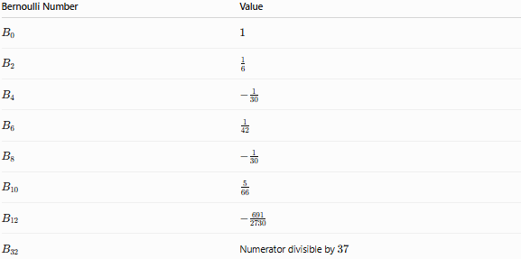
Bernoulli Number | Value
$$B_{0}$$ | $$1$$
$$B_{2}$$ | $$\frac{1}{6}$$
$$B_{4}$$ | $$-\frac{1}{30}$$
$$B_{6}$$ | $$\frac{1}{42}$$
$$B_{8}$$ | $$-\frac{1}{30}$$
$$B_{10}$$ | $$\frac{5}{66}$$
$$B_{12}$$ | $$-\frac{691}{2730}$$
$$B_{32}$$ | Numerator divisible by $37$
Only the numerators are considered when determining regularity.

Rules for Irregular Primes

1. The Number Must Be an Odd Prime
# Source: AI Source: Provided by: [Data Path: Persons Table -> ID Column: 1, Name_En Column: Motasem Essam] -> From: [ChatGPT] on [7/13/2026]
Only odd primes are classified as regular or irregular.
The prime
$$2$$
is considered regular by convention.

2. Examine the Bernoulli Numbers
# Source: AI Source: Provided by: [Data Path: Persons Table -> ID Column: 1, Name_En Column: Motasem Essam] -> From: [ChatGPT] on [7/13/2026]
For a prime
$$p,$$
consider the Bernoulli numbers
$$B_{2}, B_{4}, B_{6}, …, B_{p-3}.$$

3. Reduce Each Bernoulli Number to Lowest Terms
# Source: AI Source: Provided by: [Data Path: Persons Table -> ID Column: 1, Name_En Column: Motasem Essam] -> From: [ChatGPT] on [7/13/2026]
Each Bernoulli number must be expressed as a reduced fraction.
Example:
$$B_{12}=-\frac{691}{2730}.$$
Its numerator is
$$691.$$

4. Check Whether the Prime Divides Any Numerator
# Source: AI Source: Provided by: [Data Path: Persons Table -> ID Column: 1, Name_En Column: Motasem Essam] -> From: [ChatGPT] on [7/13/2026]
If
$$p$$
divides at least one numerator,
then
$$p$$
is an irregular prime.
Otherwise,
it is a regular prime.

5. Every Odd Prime Is Either Regular or Irregular
# Source: AI Source: Provided by: [Data Path: Persons Table -> ID Column: 1, Name_En Column: Motasem Essam] -> From: [ChatGPT] on [7/13/2026]
These two classifications are mutually exclusive and collectively exhaustive for odd primes.

6. There Are Infinitely Many Irregular Primes
# Source: AI Source: Provided by: [Data Path: Persons Table -> ID Column: 1, Name_En Column: Motasem Essam] -> From: [ChatGPT] on [7/13/2026]
It has been proven that infinitely many irregular primes exist.
Likewise, there are also infinitely many regular primes.

First Irregular Primes
# Source: AI Source: Provided by: [Data Path: Persons Table -> ID Column: 1, Name_En Column: Motasem Essam] -> From: [ChatGPT] on [7/13/2026]
The first irregular primes are
$$37, 59, 67, 101, 103, 131, 149, 157, 233, 257, 263, 271, 283, 293, 307,…$$
The smallest irregular prime is
$$37.$$

Examples
# Source: AI Source: Provided by: [Data Path: Persons Table -> ID Column: 1, Name_En Column: Motasem Essam] -> From: [ChatGPT] on [7/13/2026]
Example 1
Determine whether
$$37$$
is an irregular prime.
Among the Bernoulli numbers to examine is
$$B_{32},$$
whose numerator is divisible by
$$37.$$
Therefore,
37 is an irregular prime.

Example 2
Determine whether
$$59$$
is an irregular prime.
One of the required Bernoulli numerators is divisible by
$$59.$$
Therefore,
59 is an irregular prime.

Example 3
Determine whether
$$13$$
is an irregular prime.
None of the Bernoulli numerators
$$B_{2}, B_{4}, B_{6}, B_{8}, B_{10}$$
are divisible by
$$13.$$
Therefore,
13 is not an irregular prime.
It is a regular prime.

Example 4
Determine whether
$$101$$
is an irregular prime.
A required Bernoulli numerator is divisible by
$$101.$$
Therefore,
101 is an irregular prime.

Irregular Pairs
# Source: AI Source: Provided by: [Data Path: Persons Table -> ID Column: 1, Name_En Column: Motasem Essam] -> From: [ChatGPT] on [7/13/2026]
For an irregular prime $p$, each index $2k$(with $2≤2k≤p-3$) such that $p$divides the numerator of $B_{2k}$is called an irregular pair $\left(p , 2k\right)$.
Example
For
$$37,$$
the irregular pair is
$$(37, 32).$$
Some irregular primes have more than one irregular pair.

Common Irregular Primes
# Source: AI Source: Provided by: [Data Path: Persons Table -> ID Column: 1, Name_En Column: Motasem Essam] -> From: [ChatGPT] on [7/13/2026]
Some well-known irregular primes are
$$37, \\ 59, \\ 67, \\ 101, \\ 103, \\ 131, \\ 149, \\ 157, \\ 233, \\ 257.$$

How to Determine Whether a Prime Is Irregular
# Source: AI Source: Provided by: [Data Path: Persons Table -> ID Column: 1, Name_En Column: Motasem Essam] -> From: [ChatGPT] on [7/13/2026]
- Verify that the number is an odd prime.
- List the Bernoulli numbers
$$B_{2}, B_{4}, …, B_{p-3}.$$
- Reduce each Bernoulli number to lowest terms.
- Examine the numerators.
- If the prime divides at least one numerator, it is an irregular prime.

Real-Life Applications
# Source: AI Source: Provided by: [Data Path: Persons Table -> ID Column: 1, Name_En Column: Motasem Essam] -> From: [ChatGPT] on [7/13/2026]
Irregular primes are primarily used in:
- Algebraic number theory
- Research on cyclotomic fields
- Class number theory
- Fermat's Last Theorem
- Computational mathematics
- Mathematical software
- Pure mathematics research

Real-Life Examples
# Source: AI Source: Provided by: [Data Path: Persons Table -> ID Column: 1, Name_En Column: Motasem Essam] -> From: [ChatGPT] on [7/13/2026]
1. Fermat's Last Theorem
Ernst Kummer introduced irregular primes while studying Fermat's Last Theorem. He proved the theorem for all regular prime exponents, making irregular primes the remaining difficult cases.

2. Cyclotomic Fields
Irregular primes influence the arithmetic properties of cyclotomic number fields and their class numbers.

3. Computational Mathematics
Large-scale computations identify irregular primes by testing divisibility of Bernoulli numerators.

4. Modern Number Theory
Irregular primes continue to play an important role in research on algebraic number theory and arithmetic geometry.

Common Mistakes
# Source: AI Source: Provided by: [Data Path: Persons Table -> ID Column: 1, Name_En Column: Motasem Essam] -> From: [ChatGPT] on [7/13/2026]
- Confusing irregular primes with composite numbers.
- Assuming "irregular" refers to irregular spacing between primes.
- Forgetting that the definition depends on Bernoulli numbers, not prime gaps.
- Confusing irregular primes with strong, weak, or balanced primes.
- Forgetting that 2 is regular by convention and is not considered an irregular prime.

Key Points
# Source: AI Source: Provided by: [Data Path: Persons Table -> ID Column: 1, Name_En Column: Motasem Essam] -> From: [ChatGPT] on [7/13/2026]
- An irregular prime is an odd prime that divides the numerator of at least one Bernoulli number $B_{2}$through $B_{p-3}$.
- The smallest irregular prime is 37.
- Every odd prime is either regular or irregular.
- Irregular pairs identify the specific Bernoulli numbers responsible for irregularity.
- Irregular primes were introduced by Ernst Kummer.
- They are fundamental in algebraic number theory and the historical development of Fermat's Last Theorem.

Irregular Primes vs. Regular Primes
# Source: AI Source: Provided by: [Data Path: Persons Table -> ID Column: 1, Name_En Column: Motasem Essam] -> From: [ChatGPT] on [7/13/2026]
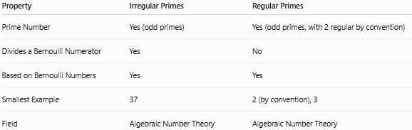
Property | Irregular Primes | Regular Primes
Prime Number | Yes (odd primes) | Yes (odd primes, with 2 regular by convention)
Divides a Bernoulli Numerator | Yes | No
Based on Bernoulli Numbers | Yes | Yes
Smallest Example | 37 | 2 (by convention), 3
Field | Algebraic Number Theory | Algebraic Number Theory

Irregular Primes vs. Strong Primes
# Source: AI Source: Provided by: [Data Path: Persons Table -> ID Column: 1, Name_En Column: Motasem Essam] -> From: [ChatGPT] on [7/13/2026]
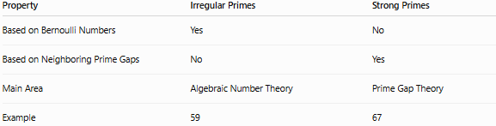
Property | Irregular Primes | Strong Primes
Based on Bernoulli Numbers | Yes | No
Based on Neighboring Prime Gaps | No | Yes
Main Area | Algebraic Number Theory | Prime Gap Theory
Example | 59 | 67

Conclusion
# Source: AI Source: Provided by: [Data Path: Persons Table -> ID Column: 1, Name_En Column: Motasem Essam] -> From: [ChatGPT] on [7/13/2026]
An irregular prime is an odd prime number that divides the numerator of at least one Bernoulli number $B_{2},B_{4},…,B_{p-3}$. Introduced by Ernst Kummer, irregular primes are the complement of regular primes and are a cornerstone of algebraic number theory. They played a crucial role in Kummer's work on Fermat's Last Theorem and continue to be important in the study of cyclotomic fields, class numbers, and Bernoulli numbers. The smallest irregular prime is 37, and every odd prime is either regular or irregular, but never both.

